horizontal line

**Charging and discharging of a capacitor**

# OVERVIEW

We know that capacitor store charge. But the process of storage is not instantaneous.We will study about charging and discharging behavior of Capacitor. In this experiment, we will study charging a capacitor by connecting it to an emf source through a resistor. The experiment also includes the study of discharging phenomena of a capacitor through a resistor.

# GOALS

1. To study charging and discharging process through capacitors

# Equipment to be Used

* Breadboard
* 220 kΩ resistor.
* 3300 μF (16V) aluminium capacitor.
* Multimeter.
* Stopwatch.
* Connection wires.
* 8.2 uF ceramic capacitor
* 6V, 9V battery

# 

# 

## Theory

## Charging a Capacitor:

Consider a circuit as shown in Figure 1 Capacitor C is initially uncharged, by closing the switch S a current i is setup in the loop and the capacitor begins to charge. Applying Kirchoffs loop rule, we get

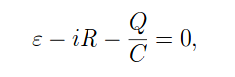 (1)

Where ε is the electromotive force (dc voltage supply), R is the resistor,

Q is the charge of the capacitor and C is the capacitance. Substituting dQ/dt

for the current i, Equation (1) becomes

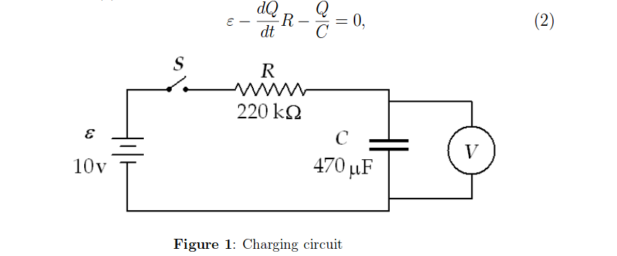

Rearranging the terms, Equation (2) becomes

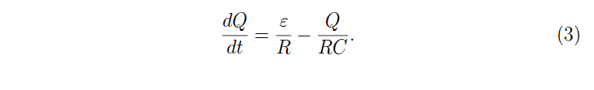

The solution of Equation (3) is given as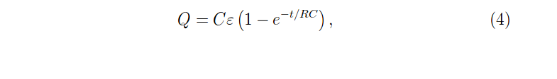

which determines the charge on the capacitor as a function of time t .

Ce = Qo

, which represents the maximum charge the capacitor can hold for a given

Emf . The voltage across the capacitor V is given as

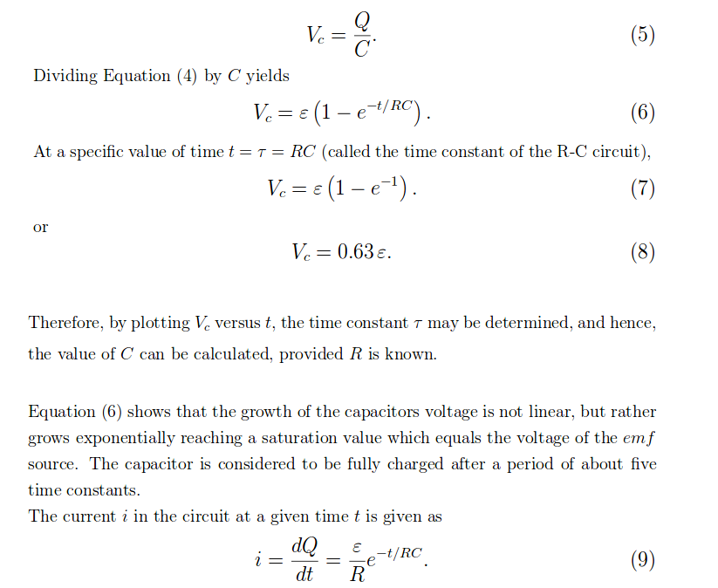



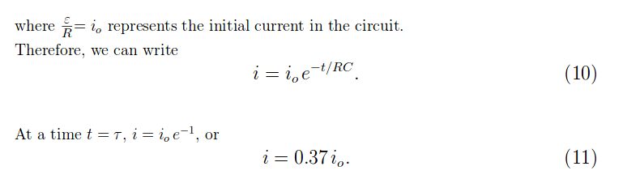

**Discharging a Capacitor:**

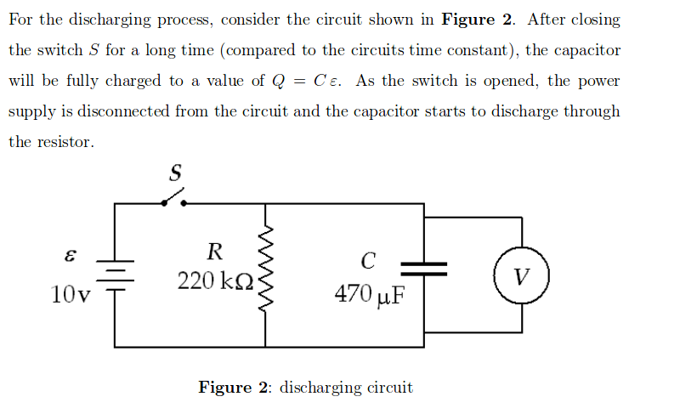

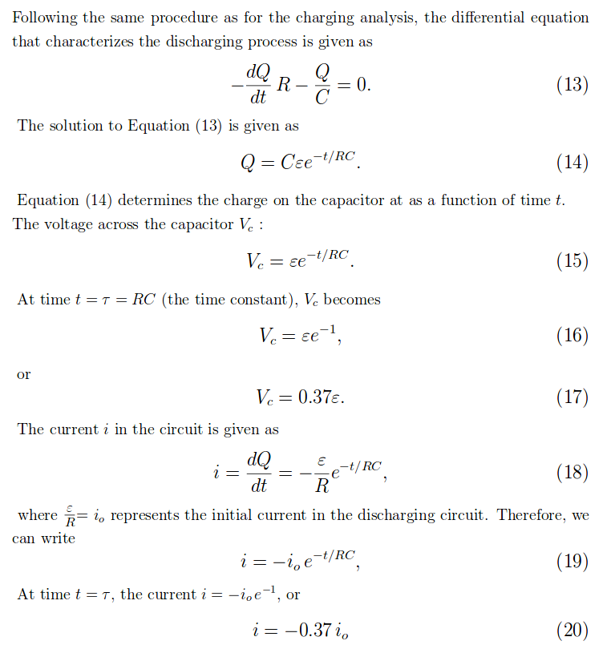



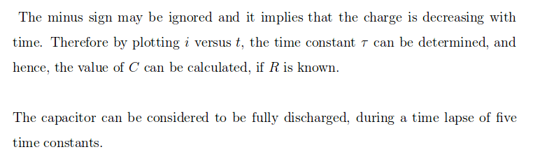





**Observations:**

* **When 3300uF capacitor was used**
  + **On charging**
  + **On Discharging**
* **When 8.2uF capacitor was used**
  + **On charging**
  + **On Discharging**
* **Effect of Resistance on the observation**
  + **On charging**
  + **On Discharging**
* **Effect of capacitance on observation**
  + **On charging**
  + **On Discharging**
* **What is L.E.D. ? How it is operated ?**

**Here is Q.R. Code to the video for the practical that I conducted!**



**Video when I connected 3300uF capacitor**



**Video when I connected 8.2uF capacitor**

**Watch the video and P.S :)**